

Shapes

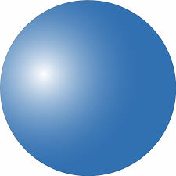

**Cube**

|  |
| --- |
| Cone |

|  |
| --- |
| Sphere |

**Cylinder**

**Square**

**Rhombus**

**Rectangle**

**Hexagon**

**Triangle**

Cone